1. select *

from emp

where deptno = 10;

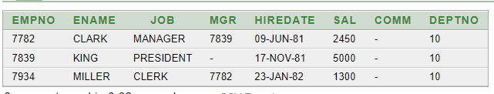

1. select ename, job, deptno

from emp

where job = 'CLERK';

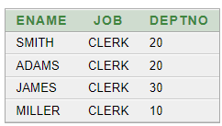

1. select ename, job, deptno

from emp

where ename = 'JAMES';



1. select ename, sal, comm

from emp

where sal <= comm;

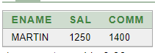

1. select ename, sal

from emp

where sal between 1000 and 1500;

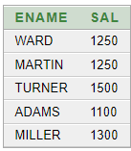

1. select ename, sal, mgr

from emp

where mgr in (7902, 7566, 7788);

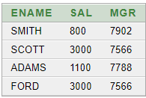

1. select ename

from emp

where ename like 'S%';

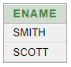

1. select ename

from emp

where ename like '_A%';

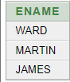

1. select ename, mgr

from emp

where mgr is NULL;

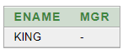

1. select empno, ename, job, sal

from emp

where sal >= 1100

and job = 'CLERK';

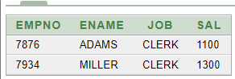

1. select empno, ename, job, sal

from emp

where sal >= 1100

or job = 'CLERK';

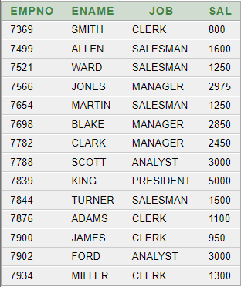

1. select empno, ename, job

from emp

where job not in ('CLERK', 'MANAGER', 'ANALYST');

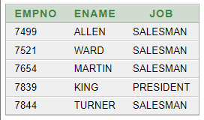

1. select empno, ename, job, sal

from emp

where (job = 'SALESMAN'

or job = 'PRESIDENT')

and sal > 1500;

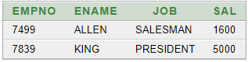

1. select empno, ename, job, sal

from emp

where job = 'SALESMAN'

or job = 'PRESIDENT'

and sal > 1500;

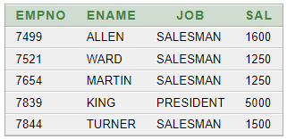

1. select ename, job, deptno, hiredate

from emp

order by hiredate;

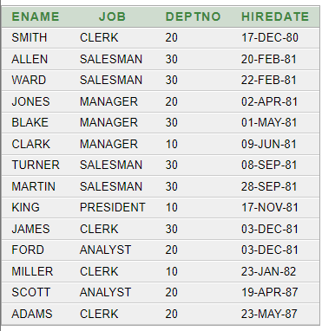

1. select ename, job, deptno, hiredate

from emp

order by hiredate DESC;

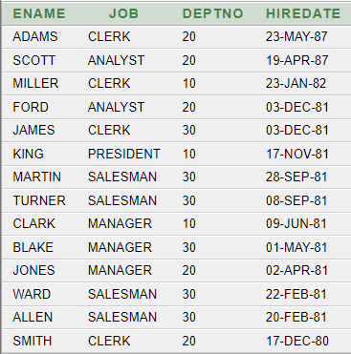

1. select empno, ename, sal*12 annual

from emp

order by annual;

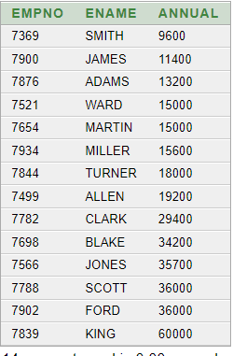

1. select ename, deptno, sal

from emp

order by deptno, sal DESC;

